Assignments -2 :

1)Tableau data engine is the panted software of tableau corp which is used for Extract creation,data refreshes and fast query response time.(Hyper is the TDE name from 10.5)

2)Right click on any of the dimensions or measure to create a calculated field.

3)Treemap: Represents data a block of different sizes arranging them as a tree structure from highest kept measures and color intensity.

Heatmap: Represents data a block of different sizes arranging them from highest kept measures and color intensity against multiple dimensions.

4)Different components of a dashboard are : Canvas to drop objects,Objects pane,sheets,Size,Layouts.

5) a) sum(sales) from previous years customers : 725,703

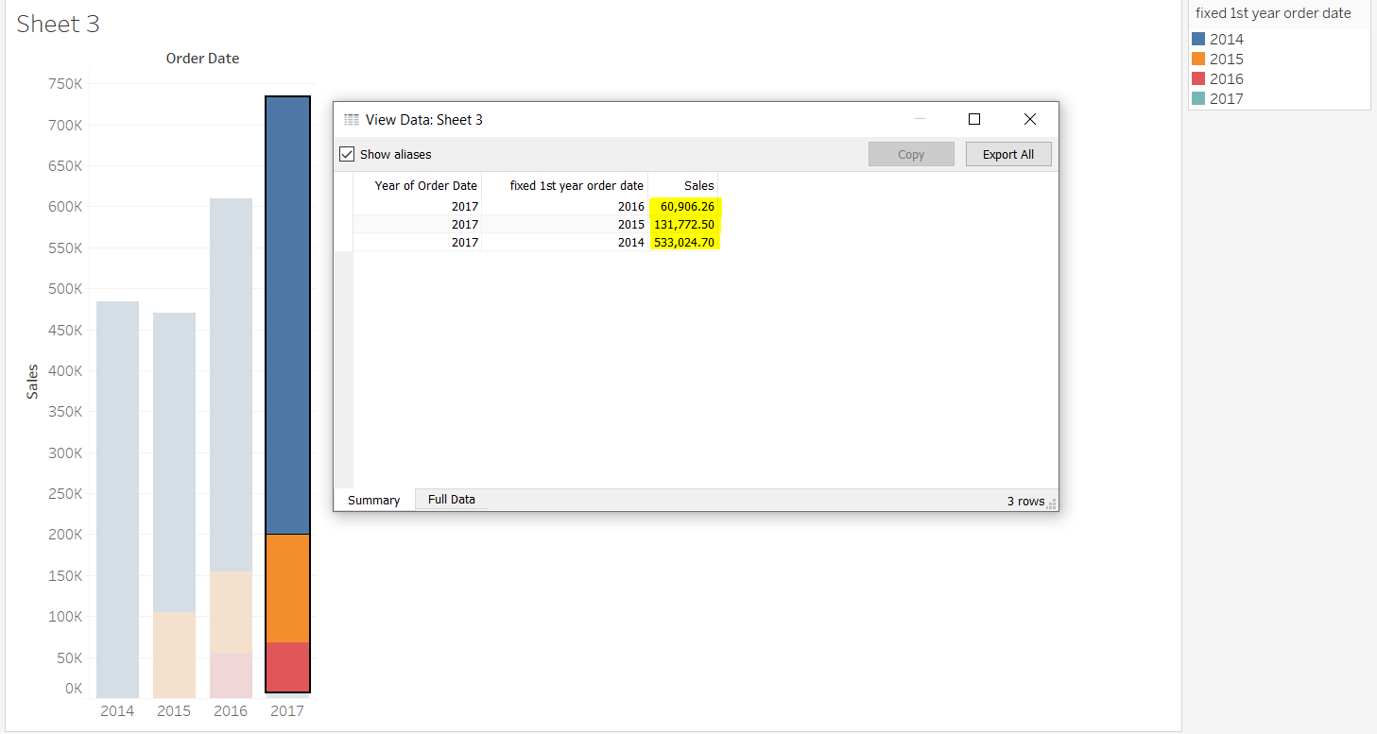

b)98.98% has been contributed by previous years customers in 2017(current year as per sheets’data)

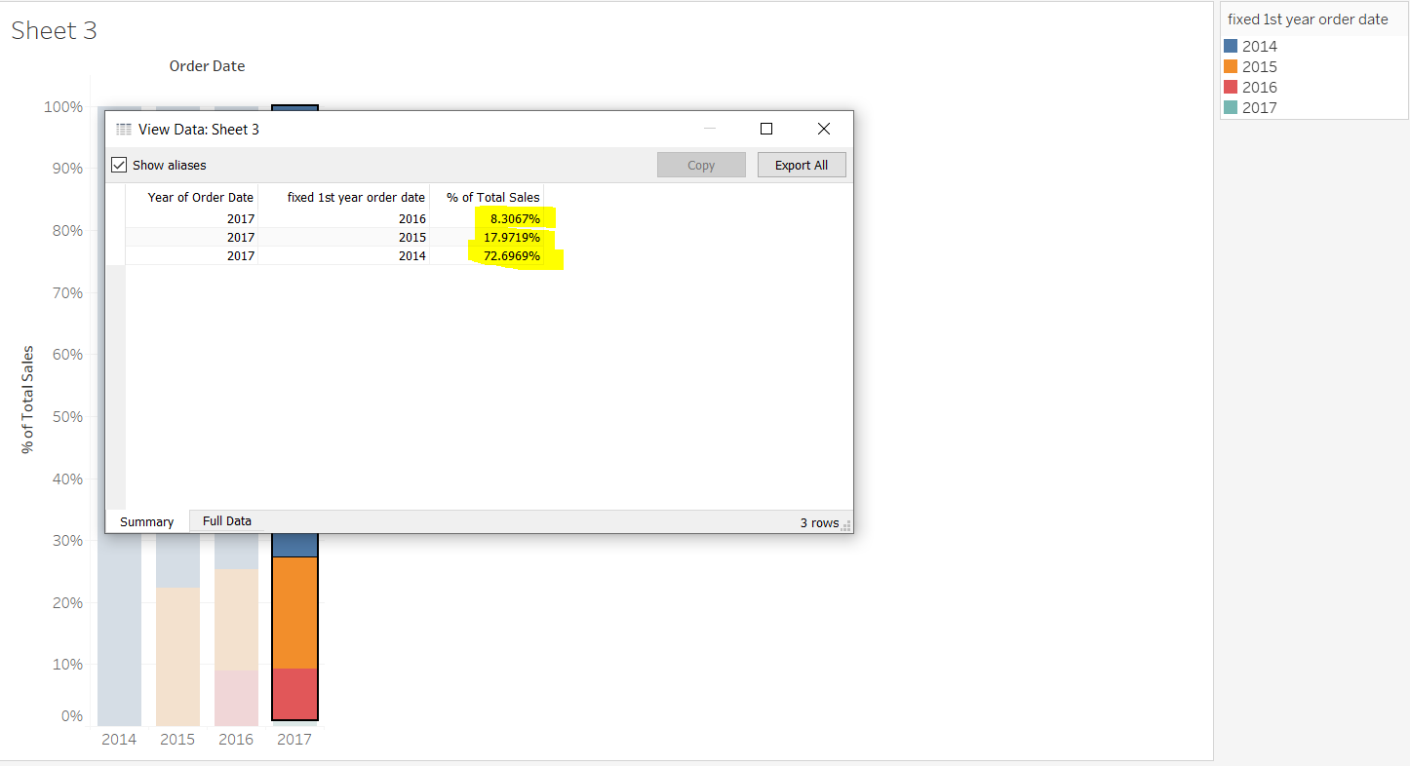

c) 